Sac City Public Library
Strategic Action Plan
2018-2023
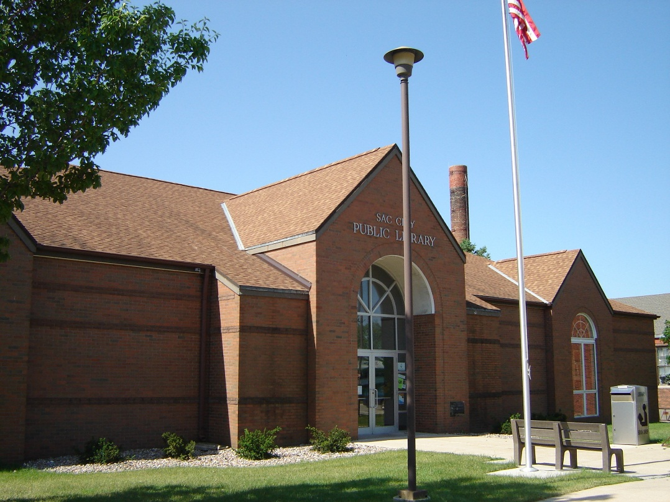

Adopted
November 2nd, 2017
Approved with Revisions
March 1, 2018, March 5, 2020

Mission of the Sac City Public Library
The Sac City Public Library is the link to your community – a comfortable welcoming place where people of all ages enjoy and contribute to life-long learning.
The Vision of the Sac City Public Library
The Sac City Public Library is a learning community. Educational, cultural, social and recreational activities will be made available to the community in an environment that is both attractive and conducive to learning.
The Planning Process
The Library’s strategic action plan adopted on April 7th, 2011 identified the following three objectives: Know Your Community, Lifelong Learning, and Visit a Comfortable Place.
The first goal of the 2011 plan was for Sac City’s residents to have a central source of information about the community’s available programs. It was determined that progress was made with respondents of the 2014 community library survey indicating that 85 of 103 (83%) library resources were used to find our information about community programs and library services. The objective of the creation of a community calendar was not met. The objective of creating community welcome bags was revised, by the Library gifting new parents board books for babies and including information about library programs and community resources. The Library did partner with the Chamber Main Street to include library programs and events on the chamber website.
The Second Goal of the 2011 plan required for citizens of all ages to have the resources and support they need to inspire and challenge themselves as lifelong learners. Information collected from library surveys showed that, in general, there were increases in program attendance for participants of all ages. It was a goal of the Library to host Civil War Sesquicentennial event in 2011, this goal was not met. The Library did host a series of movies for adults. It was found that these programs were not well attended, and therefore, were suspended in favor of more popular programs. Interestingly, the Library found that movies were very popular with children, and the Library continues to offer monthly movie programming for youth. The Library was able to purchase a temporary sign to advertise programs street side.
The Third Goal of the 2011 plan required the Library to create a warm and inviting place to meet with others. The objective for the goal was for continued measurable increases in the use of the Library’s meeting rooms by the public. This goal was met with 2015 having the strongest usage with 572 meetings. The Library has recently installed a patron counter to help staff keep a more accurate count of patron usage of our facilities. The Library also successfully updated its policies for meeting room use and patron conduct.
The library also regularly posts pictures and updates of our space and resources on social media and in the weekly newspaper column. The Library has not been successful in securing funds to digitize its newspaper collection.
The Fourth Goal indicated that adults and teens would have the equipment and support needed to keep pace with changing technologies. It was an objective that the Library would have success in increasing attendance in its computer classes. This has not been met, as it has been observed that the technology needs of Sac City are evolving. Many patrons are requiring 1 on 1 assistance with personal devices rather than classes. We also receive requests to hold specialized small classes for organizations such as business and industry or the local Chamber of Commerce. Our daily patrons are choosing not to attend scheduled classes. We were successful in purchasing additional laptops (Chromebooks) for in-house use which have been popular with our patrons.
A second objective tied to Goal #4 called for an increase in digital resource use. We have seen a continual increase in the use e-books, and database use which have coincided with a decrease in the circulation of traditional library materials.
GOALS 2018 – 2023
In June of 2014, the library delivered a public survey of library services to the community of Sac City via mail, survey monkey.com and were also available at the library circulation desk. Respondents were asked, “How do you find out about what is happening at the Library?” The top responses were: Word of Mouth, Newspaper, and Library Staff. 78 or 76% of respondents indicated that they were over 50 years of age. Given that respondents preferred to receive information through traditional means of delivery and given few respondents were from a younger age demographic the Board of Trustees decided focus our first goal on community visibility.
Goal #1 Visibility – Sac City residents will know the library, as a city service, to be actively engaged in community life.
OBJECTIVES:
- The Library staff will identify and participate in community events (particularly non-traditional) that offer exposure to the Library and its services.
  - In 2018 and each subsequent year of this plan, the Library Director or Children’s Librarian will identify and attend 3 community events (e.g. school orientation evening, county fair) to attend annually to promote library events and patron registration.
    - This goal was accomplished with library staff attending: Celebrate Sac County, Sac County Fair, Sac City Museum annual celebration
- The Library will increase efforts to collaborate with local media to gain exposure for library events and programs.
  - In 2018 and each subsequent year of this plan, The Library Director will submit no less than 4 press releases outside the library annually advertising library programs and services.
    - This goal has been modified to include other forms of media.. The library has incorporated advertising in the City’s monthly bill insert, the City’s monthly water bill insert, the Sac Sun, and area radio.
- The Library will create an emblem/brand to use to use in the promotion of all library service by June 30th, 2021.
  - The library accomplished this goal in 2019.
- The Library will secure funding for the placement of a digital sign on its grounds to promote its programs by June 30th, 2018.
  - This goal was accomplished through a gift of the Criss fund.
The Library Board of Trustees compared the number of annual visits received to the Sac City Public Library with the average patron visits reported in the Iowa Public Library Statistics July 1, 2015 – June 30, 2016. According to State Library data, the average attendance for a size C library was 15, 834. Sac City Public Library reported 9,718 patron visits, placing just above the 25th percentile among other C libraries in the state of Iowa. Like many rural counties in Iowa, Sac County population is aging. Accessibility to library services is a concern.
Goal #2 Access to Services - Sac City residents will enjoy increased avenues of access to library services.
OBJECTIVES:
- The Library will institute a policy and services for homebound delivery service by August 30th, 2018 to begin no later than October 1st, 2018.
  - This goal was accomplished
- The Library will develop and deliver a community needs for library services by January 31st, 2021.
- Develop a marketing campaign to promote the library’s digital resources to the public by June 30, 2019
The library’s budget history shows that it has remained stagnant for years. According to the Iowa Public Library Statistics, July 1, 2009 – June 30, 2010 and the Iowa Public Library Statistics July 1, 2015 – June 30, 2016, The City of Sac City’s contribution to the library budget has increased by only 2.6% in six fiscal years from $74,964 in 2010 to $76, 915 in to 2016. Our situation will not improve in coming fiscal years. The Board of Trustees recognizes that a good way to combat stagnation is through building local partnerships. By working with other organizations, we have the potential to share knowledge and expertise, improve access to library and share community resources.
Goal #3 Partnerships – Sac City residents will see the public library as a civic partner, as well as a collaborator with area arts and education efforts.
OBJECTIVES:
- The Library will collaborate with local schools to display student art in the library by October 31st, 2018.
  - This goal was not accomplished due to disinterest of the elementary school.
- In 2018 and each subsequent year of this plan the Library will recognize and thank current partners by holding an appreciation coffee for Friends and volunteers.
  - The library amended this goal to include the Chamber Mainstreet and invite local partners.
- By July 1, 2019, the library will seek a partnership with the local museum to allow for shared local collections.
  - This goal was accomplished in 2019 through the distribution of local high school annuals and a collaboration of the Abraham Lincoln program.
- By September 2018, the library will collaborate with 2 local business to develop a series of library programs featuring the talents of local residents (e.g. food series program.)
  - This goal was partially accomplished through a cookie decorating workshop with Granny B’s Bakery.

On April 28, 2015, the City of Sac City released its Goal Setting Report commissioned by the Institute of Public Affairs (IAP) for the community. Among the Issues, Concerns, and Opportunities identified by the public were: Poor Community Atmosphere, Shortage of Available Workforce, Low Quality Education. Based on this information, the Board of Trustees felt the library should place an emphasis on placemaking. Our library is a draw for community and economic development and its attractiveness needs to be parallel in both service and appearance. It has not had any building updates since opening in 1989.
Goal #4 Sac City residents of all ages will benefit from a modern, comfortable, and welcoming 21st century library
OBJECTIVES:
- The Sac City Library will seek financial resources to update its infrastructure by June 30th, 2018.
  - This project was complete in 2019 with the update of library lighting, carpeting, paint and overhaul of the Teen Scene.
- Replace existing furniture in the Teen Scene with attractive and modern furnishings by June 30th, 2018.
  - This goal was accomplished in July, 2020 with the addition of age appropriate furniture.
- Weed and configure collections to ensure room for growth by June 30th, 2018.
  - This goal was accomplished May 2020.
- Complete an additional priority on the ADA Accessibility Checklist for Readily-Achievable Barrier ensure compliance. by June 30th, 2022.

INTERNAL OPERATIONS
The Sac City Public Library will continue to provide its staff with continuing education by utilizing opportunities offered through regional, state, and national classes and webinars as they are available and relevant. The Library will continue to employ a certified director and encourage the remainder of its staff to seek continuing education opportunities when available.
Budget
The Sac City Public Library budget has remained stagnant for the past several years. The library board will continue to seek increased City and County funding to preserve the programs and services that are currently offered and expand when possible. The board of trustees and the director will also continue to pursue more outside funding through grants and gifs to the Friends of the Sac City Library and the Sac City Library Foundation.
Evaluation
The goals of the 2018-2023 Strategic Action Plan will be measured by both statistics and patron satisfaction. We will continue to closely monitor patron usage and attendance through our patron counter, daily statistics and reports generated from our ILS. We will draw upon information collected in the State Library of Iowa Annual Survey and local satisfaction surveys for comparison.

Additional Goals –
Update the children’s play area with fresh toys.
Digitize genealogy resources.
Replace landscaping in the rear of the library.
Update door handles in public service areas
Replace weather stripping on front and back door.
Update library webpage to Concrete 5.

